
GRIDNODE PTE LTD

TRANSACTION MONITORING™
Transaction Monitoring Report Generation
Development Guide

Release version 1.0

TRANSACTION MONITORING™
Transaction Monitoring Report Generation Development Guide

Contents

Chapter Page

Related Documentation i
1 Overview 2
1.1 Servlet 2
1.2 MBean 2
1.3 Session Bean 2
2 Report Generator 4
2.1 How JasperReport was generated 5

Related Documentation

The following documents directly support Transaction Monitoring Report Generation Development Guide:
- Transaction Monitoring User Guide
- Transaction Monitoring Report Generation Building Report Guide

1 Overview

1.1 Servlet
The primary role of this module is to generate report base on end-user’s needs. Therefore, the criteria to generate a report are being passed from the User Interfaces via servlets. Each servlets is triggered when the web page has submitted some data from the User Interfaces to the system. There are six servlets currently, and they are:

- CreateReportServlet.java
Allow end-user’s to Run Reports Now (both View Online function and Send Email function)

- CreateScheduleServlet.java
Allow end-user’s to Create a Schedule Report

- GenerateReportServlet.java
Allow end-user’s to generate a report to be viewed online.
After generation of this report, it is not persisted into database.

- HousekeepReportServlet.java
Allow end-user’s to schedule a deletion of generated report in the database

- UpdateScheduleServlet.java
Allow end-user to edit existing schedule reports and update it to the database

- ViewReportServlet.java
Allow end-user to View reports which have been generated before and thus only those which are stored in the database.

Each servlets serves different functions which will be mentioned later in this guide.

1.2 MBean
The secondary role of this module is to schedule a generation of report using Managed Beans (mbean). There are two functions running at the mbean currently, and they are:

- To delete report
- To generate report

The individual functions will be discussed later in this guide.

1.3 Session Bean
This module uses two stateless session beans in the EJB container. Both of them have the similar functionality. The reason why they are being separated is because GenReportHandlerBean is handling with Report object, while GenScheduleHandlerBean is handling with Schedule object.

- GenReportHandler Session Bean
GenReportHandlerBean.java

- GenScheduleHandler Session Bean
GenScheduleHandlerBean.java

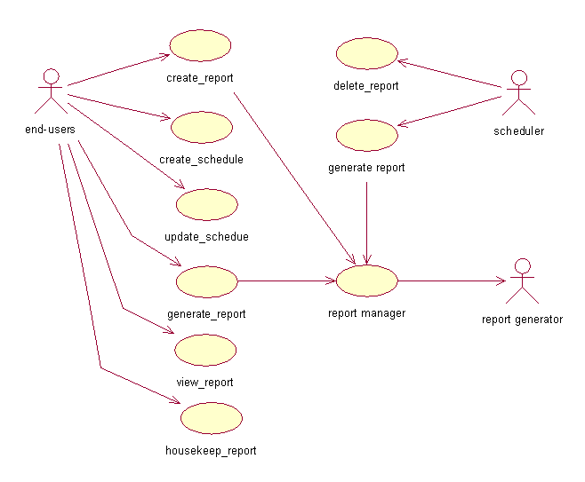

Create_Report Use Case
Allows end-user to select the Run Reports Now function in the UI and clicked on the View Online button or Send Email button.

Create_Schedule Use Case
Allows end-user to select the Create New Schedule function in the UI and clicked on the Submit button.

Update_Schedule Use Case
Allows end-user to edit a particular record in the List Of Schedule page and clicked on the Edit button. And thus the update button was clicked after editing the information in the Update Schedule Report page.

Generate_Report Use Case
Allows end-user to click on the Generate button in the List Of Schedule page.

View_Report Use Case
Allows end-user to click on the View button in the List Of Report page.

Housekeep_Report Use Case
Allows end-user to select the Housekeep Report function in the UI and clicked on the Edit button. And thus, the Update button was clicked after editing the information in the Housekeep Report page.

Delete_Report Use Case
This is triggered by the JBOSS schedule providers. The interval of the service is every one minute when it will query the database.
Query:
SELECT * FROM “rpt_report”
WHERE (“created_date_time” + “archive_duration”) – SYSDATE < 0

Generate_Report Use Case
This is triggered by the JBOSS schedule providers. The interval of the service is every one minute when it will query the database.
Query:
SELECT * FROM “rpt_schedule”
WHERE “next_run_date_time” >= ?
AND “next_run_date_time” <= ?
(1st question mark refers to a start range date time
2nd question mark refers to an end range date time)

Report Manager Use Case
This manager aims to validate the report format required to be generate. (For example in *.txt, *.pdf, *.html, *.rtf, *.xls, *.xml) Base on the format required. The manager will call the appropriate JRExporter.

After gathering the necessary information from the input of end-user and converting them into requirements of generating a JasperReport, the manager will call a Report Generator (Either GenerateJReport or GenerateScheduleJReport base on the generation needs).

2 Report Generator
There are two classes which are directly related in generating of JasperReports – GenerateJReport.java and GenerateScheduleJReport.java.

Class Name | Object Related | Main Methods | Originates From (User Inteface)
GenerateJReport.java | Report Object | - generateReportViewOnline()  - generateReportSendEmail() | - Run Reports Now > View Online button  - Run Reports Now > Send Email button
GenerateScheduleJReport.java | Schedule Object | - generateReportViewOnline()  - generateReportSendEmail() | - List Of Schedule table > Generate button  - JBOSS Schedule Provider (triggered from backup)

Differences between the two main methods
generateRpeortViewOnline() | generateReportSendEmail()
Involves an OutputStream | Does not involves an OutputStream
Output report is not persisted in database | Output report is persisted in database

2.1 How JasperReport was generated
Step 1: Define a specific JRExporter to be used

For example in ReportManager.java:

JRExporter exporter = null;
if ("pdf".equals(outputType))
{
exporter = new JRPdfExporter();
}

Step 2: Retrieve the absolute path of the report template (*.jrxml)

For example in GenerateJReport.java:

JasperReport jasperReport = null;
jasperReport= jasperCompileManager.compileReport(getReportMain(reportTemplate));

Step 3: Gather all report parameters (8 parameters so far and all are mandatory)

For example in GenerateJReport.java:

parameter.put("REPORT_TIME_ZONE", _tz);
parameter.put("customer_name", customer);
parameter.put("start_time", nextStartDateTime);
parameter.put("end_time", nextEndDateTime);
parameter.put("image_dir", imagePath+IReportConstants.IMAGE_PATH);
parameter.put("image_title", getPropertyValue(_imageTitle));
parameter.put("image_smallLogo", getPropertyValue(_imageSmallLogo));

Step 4: Define JasperPrint with the associated datasource
This is to allow JasperReport to retrieve data from the database in order to generate report.

For example in GenReportHandlerBean.java:

JasperPrint jasperPrint = null;
jasperPrint = JasperFillManager.fillReport(jasperReport, parameter, con);

Step 5: Export report to a temporary folder

For example in GenerateJReport.java:

exporter.exportReport();

Step 6a: Download the report from temporary folder to allow report to be viewed online

For example in GenerateJReport.java:

File file = new File(getEnginePath(filename));
InputStream is = new FileInputStream(file);
long fileLength = file.length();
byte[] b = new byte[(int)fileLength];

int offset = 0;
int numRead = 0;
while(offset < b.length && (numRead = is.read(b, offset, b.length - offset)) >=0)
{
offset +=numRead;
}
if(offset < b.length)
{
_logger.logWarn(mn, params, "Could not completely read file " +file.getName() , null);
}
is.close();

response.setContentType(contentType);
response.setContentLength((int)fileLength);
response.setHeader( "Content-Disposition", "attachment; filename=\"" + file.getName() + "\"" );

ByteArrayInputStream input = new ByteArrayInputStream(b);
byte[] buffer = new byte[512];
int readSoFar = 0;
while( (readSoFar = input.read(buffer)) != -1)
{
os.write(buffer,0,readSoFar);
}
os.flush();
input.close();
status = true;

Step 6b: Retrieve the report from temporary folder and send as attachment via email

For example in GenerateJReport.java:

_fileList.add(outputFileName);

for(int i=0; i<_fileList.size(); i++)
{
File file = new File((String)_fileList.get(i));

Properties props = (Properties)updateReportSetting(report, file, reportNo);
boolean emailStatus = sendEmail(report, file, props);
file.delete();
if(emailStatus)
status = true;
}

